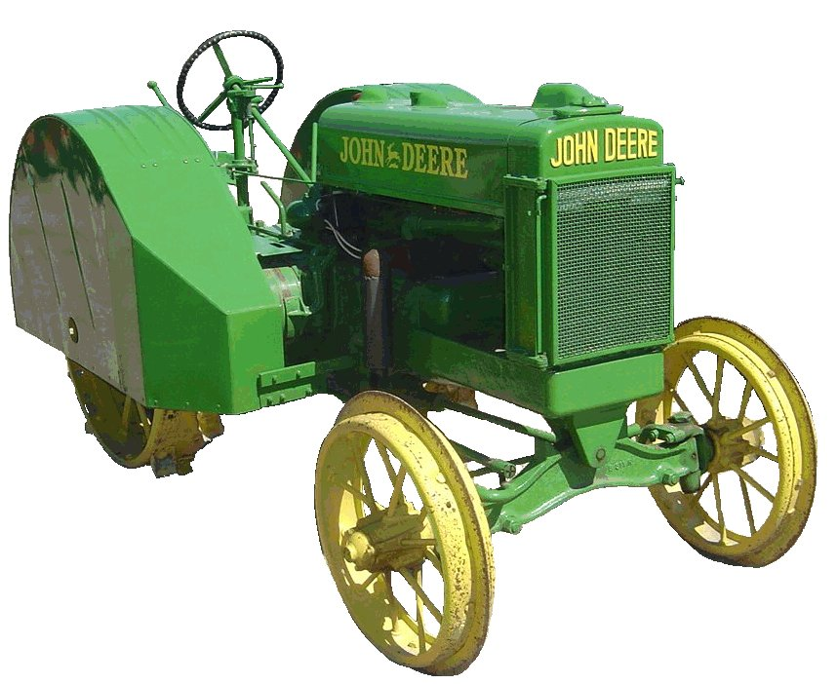
F O O T H I L L S

ANTIQUE POWER ASSOCIATION
ESTABLISHED 2003

March 2018
Dear Members,
Planning for the 2018 Antique Power Show is in full swing, particularly ad sales. Without our sponsors, the proceeds from our show would be minimal. Yes, the gate proceeds are significant and the Tee-shirt sales add up, but the funds provided by our sponsors are, by far, the biggest part of what gives us the opportunity to support the charities to which we give. Please make it a point to thank our sponsors and support them whenever you can. They deserve it.

--- --- --- the March meeting --- --- ---

- Keep praying for one another, and especially for those or of members, family, and friends in need. And don’t forget to pray for our country also.

  - Margaret Yount
  - Keith Blair
  - Vicki Danner
  - Dee Stewart
  - Reba Reinhardt
  - Jacqueline Hilliard
  - Carl Switzer
  - Wade Hefner
  - Jim Brown
  - Tammy Hoyle
  - Vee Williams (& Howard)
  - Lorna Sheets
  - Billie Sue Goforth
  - Steve Hefner
  - Vicki Hastings
  - Ira Cline
  - James Grant
  - Larry Sigmon
  - Kelly Blanton
  - Rev. Bobby Langston
  - Don Johnson
  - Carl Porter
  - Jane Abernathy
  - Kay Nash
  - Donnie Elmore

- This year is a very significant year regarding our show and our relationship with the American Legion Post 48. Since our very first show in 2003, we have had to wait until the weekly Flea Market clean-up was complete before we could enter the grounds and begin setting up for our show. This year, the Legion has graciously decided to scale back the Flea Market as they do during Fair week – placing the sales area outside the midway. By doing this we now have the opportunity to begin setting up earlier that week.
  - Grounds preparation will begin on Tuesday (mowing, speaker setup, etc.).
  - Wednesday will be the day when we can start hauling in display items. (We’ll be announcing exact times as we get closer.) Security will be on-sire Wednesday night.
  - On Thursday the Flea Market will be in operation for the duration of its normal hours but will be setup outside the fence. Since we do not want to add confusion into the mix, anyone desiring to haul in on Thursday is asked to wait till after 2PM. PLEASE do not try and circumvent the request and attempt to haul in while the Flea Market is going on. We do not want to do anything to jeopardize this newly acquired early set up because someone could not follow the rules. Security will be on-site Thursday night.
  - Friday will be a normal show day, as it always has been.

- We are very, very appreciative to the American Legion Post 48 for working with us on this and providing the opportunity for us to grow. This new availability of set up time will help us in quite a few ways.
  - The stress of set up will be lessened drastically.
  - With the added setup days, we will have a much greater chance of inviting national clubs and organizations to participate. Such participation from other states can potentially bring about significant growth of our show and our organization.

- With the added setup time, pre-registration is needed more than ever. We strongly encourage and request all exhibitors to register all the equipment brought to the show. By pre-registering, you can save time otherwise spent at the registration trailer.

- For all who will be camping in the camping area, a new method has been put in place to help organize the use of the camping area. A form is available (see Wilson) that will allow dues-paying members the opportunity to reserve a camp site and to pre-pay the $25 electrical fee (payable to the American Legion).

- We need articles for the show program. Factual information about your equipment, family stories, even personal accounts of problems you found while restoring your equipment – any and all of these are of interest and can add an extra dimension to what people will go home with after the show. Photos really make a difference, too.

- The April meeting (April 5) will be preceded by a hot dog supper starting at 6PM. We’ve had a fee meals prior to meetings over the past several months and they are great times to spend in fellowship with each other. We hope as many as can come will come.

- As of January 1 the 2018 membership renewals were due. I you have not renewed, you can do so by sending it to the club address below, bring it to the next club meeting, or see Wilson at Sig’s Tire (5851 St. Peter’s Church Road, Conover, NC) or Tim Hollar at Hollar Tractor (4436 Section House, Rd, Hickory, NC).

--- --- --- F-M Engine update --- --- ---

- The 120HP Fairbanks-Morse engine is set in place. The line shaft is in place, it has been belted up to the sawmill for testing and everything looks great. Once we get the shed in place over the engine and the lube oil, fuel system, and cooling water piping in place, we’ll be ready for the first test run. We’ll keep you posted.

-- --- --- THE CLASSIFIEDS --- --- ---

Is there anything you would like to sell or are you looking for something special? List it here.
(Item listings will run for 3 months before expiring. Let us know when an item is sold or bought.)

For Sale: 1959 Ford tractor, 2 Stover engines, Waterloo engine, JD M tractor, JD 110 mower, Wheelhorse GT14 mower. Carroll Baker 828-256-8683. (1803)

--- --- --- UP-COMING EVENTS --- --- ---

Mar 15 Sig’s Show Committee meeting
Mar 16-18 Arden Oliver-Hart-Parr Winter Get Together
Mar 31 Dallas Cotton-ginning Days Swap Meet
Apr 1 Easter Sunday
Apr 5 Sig’s April monthly meeting
Apr 13 Catawba Bandys High School Ag Day
Apr 13-14 Turnersburg Spokes & Cleats Swap Meet
Apr 13-14 Spencer Tractors & Trains Festival
Apr 19 Sig’s Show Committee meeting
Apr 21 Newton American Legion Post 48 Car Show
May 3 Sig’s May monthly meeting
May 4-5 Morganton Valley Hills Show
May 18-19 Newton FAPA 15th annual Show

☺ ☺ !!!!! HAPPY BIRTHDAY !!!!! ☺ ☺

March Birthdays

3 – Kenneth Cannon
8 – Keith Little
11 – Gary Detter

12 – Rahn Painter
19 – Jason Icard
23 – Buddy Huffman


April Birthdays

1 – Richard Blume
1 – Duane Webb
2 – James Reinhardt
3 – Bobby Franklin
3 – Dexter Sprouse
4 – Brent Henley
6 – Dennis Back

6 – Bryan Warner
7 – Don Timmerman
12 – Charles Lynch
12 – Johnny Bryant
16 – Johnny Hollar
16 – Linda Sigmon
17 – Blake Herman
19 – Michael Dagenhart
21 – Fred Little
25 – Fred Sherrill
26 – Kermit Nash
27 – Kelly Pope
28 – Angela Schronce
30 – Butch Fox
30 – Kyle Sigmon

President: Kevin Black 828-464-1950 Vice Pres: Wilson Sigmon 828-256-2176
Treasurer: Kermit Nash 828-459-9616 Secretary: David Setzer 828-850-4943
Show Chair: Teddy Hefner 828-310-5525 Asst. Show Chair: Anthony Austin 828-302-5326
Asst. Secretary: Kevin Sigmon 828-320-1419

Board of Directors: Phillip Spencer, Howard Reinhardt, Ned Story, Teddy Hefner, Tim Hollar, Butch McIntyre

Foothills Antique Power Association 5851 St. Peter’s Church Road, Conover, NC 28613
Foothillsantique.com
-- --- --- something to think about --- --- ---

Unless you are a hermit, you heard that our dear brother in Christ Rev. Billy Graham fell asleep in late February. There was a great deal of fanfare and media coverage regarding his life and his funeral, even though he himself would not have approved of the focus on him.
His death is certainly a loss, not only to those of us who had heard him preach, but to God also. Psalm 116:15 says that the death of even one of God’s people costs God a great deal. If the ravages of time and death had not taken their toll, how much more of our Lord’s work could he have accomplished?
If you looked closely and listened intently to the media coverage, you would get the idea that he had some special gift that enabled him to do what he did. However, the truth is, he and you and I are all equal in Christ – none is greater than another, none is more special than another, none is treated with more emphasis than another. God is not concerned about who we are, what we have, or what we can do; rather He is concerned about what is in our heart (1 Sam. 16:17). Rev. Graham’s heart was simple: “Here am I, send me.” (Isaiah 6:8) The simple fact is, that is why he stood out from the crowd. The overwhelming majority of Christians do not have that heart. They are content to live in the world and let others do our Lord’s work.
“To him who hath, more will be given …” (Luke 8:18).
Have you heard the gospel of Jesus Christ? Have you received God’s gracious gift? If your answer is “yes,” whether you know it or not, God has given you the task of doing our Lord’s work (2 Corinthians 5:20). If you have in your heart the willingness to do what our Lord gives you to do, he will give you everything needed to do it. Even if He inspired you to preach on the moon, He would provide the rocket ship to get you there!
Most people, though, are content to receive His gracious gift and continue living their life the way they want to live it without any thought of God or Christ. They are the ones who look to men and women like Billy Graham as special people, yet they do not know or acknowledge that they are equally as special to God and can equally do His work if they will be say in their heart “Here am I. Send me.”
I pray each and every one of you will rise up and do what our Lord has for you to do. God gave Billy Graham to speak to thousands at a time and to presidents and kings. Is it beyond reason to think that our Lord has given to you and to me the task of speaking to the person next to us today? You may doubt your own ability; do you equally doubt our Lord’?

God bless you all.
Hope to see you in April.

Your Secretary, David Setzer

Foothills Antique Power Association
^{15th} annual Antique Power Show May 18-19, 2018
Exhibitor pre-registration form

Name: _________________________________________
Address: _______________________________________
City, State, Zip: __________________________________
Phone: _________________________________________
Email: _________________________________________

Year Description Placard? (circle)

______ ________________________________________________ Color B&W

______ ________________________________________________ Color B&W

______ ________________________________________________ Color B&W

______ ________________________________________________ Color B&W

______ ________________________________________________ Color B&W

______ ________________________________________________ Color B&W

______ ________________________________________________ Color B&W

______ ________________________________________________ Color B&W

Total number of color placards desired ______ @ $2.00 ea = _________

Use back if more room is needed.
Pre-printed COLOR placards are laminated and @2.00 each. B&W placards are no charge.
If placards are desired, please indicate your preference.

Please complete and return by May 1.
Forms and color placard payment can be mailed to Foothills Antique Power Assoc. at the address below, or they may be delivered to David Setzer or Kevin Sigmon at the regular meetings, show committee meetings, or via Sig’s Tire.

You can also easily register on line, just go to www.foothillsantique.com.

5851 St. Peter’s Ch. Rd. Conover, NC 28613
Foothills Antique Power Association
Reservations and Electrical Power Form
15th Annual Power Show May 18th and 19th, 2018

Campground Sites
To reserve a Campsite in the Campground at the Show you are required to be a member of Foothills Antique Power Association and are required to pay the $25.00 Electrical Fee. Anyone who is not an existing member and would like to reserve a site will need to join for $20.00. This Membership will cover your Admission for the duration of the show.

Food Vendors
All Food Vendors are required to pay a $25.00 Electrical Fee.

Show Space(s) with Power
Anyone displaying in the show grounds and using Electricity at a camper are required to pay an Electrical Fee of $25.00

(Please select one)

_______ I am a member and I need to Reserve a campsite in the campground and Pay my Electrical Fee. $25.00

_______ I am not a member. I need to Join Foothills Antique Power Association and Pay my Electrical Fee on a Campsite I am reserving. $45.00

_______ I Have a reserved show space and plan on using Electricity during the show. $25.00
_______ I am a food vendor and plan on using Electricity during the show. $25.00

Name_____________________________________________ Date_________________
Address ________________________________________________________________
City ______________________ State ________________ Zip_____________________
Phone Number______________________ Site Number (If Applicable) ____________

Please send all forms and money to Foothills Antique Power Association. 5851 St. Peters Church Rd Conover, NC 28613. To Reserve a show space please call Anthony Austin at (828) 302-5326. To reserve a Campsite Please call Teddy Hefner (828) 310-5525. For Questions regarding Electrical Fees please call Charles Bentley at (828) 850-3286.
We will mail you a card to display on your power pole that’s says that your electrical Fee Has Been Paid.

